Algebra 1: Unit 12, Lesson 5

- The number of CDs sold at a local music store in the years since 2002 is shown in the scatter plot.
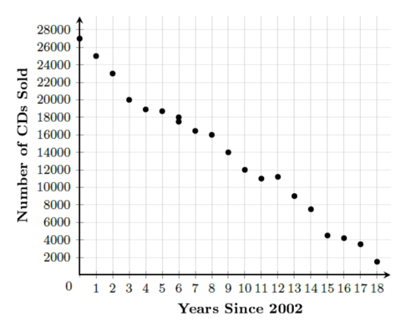
Determine if the data is strong or weak, positive or negative, and linear or nonlinear.
Strong, negative, and linear

- There is a strong positive association between the Grade Point Average (GPA) and height, in inches (in.), among students at Rosemary High School.
The positive association shown in the study does not mean that being taller ensures a higher GPA. This is an example that shows _____________________ does not imply _____________________.
Correlation, causation

- The scatterplot shown summarizes the relationship time spent studying, in hours, and the scores on an Algebra 2 math test among Mrs. Smith’s students.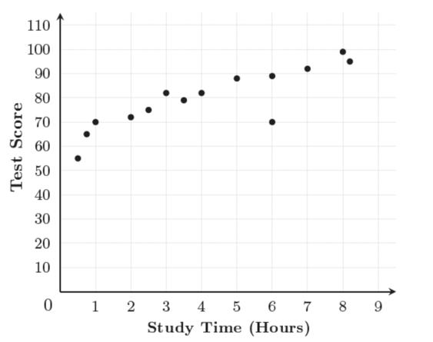
What is the relationship between the time spent studying and the test score?
As time spent studying increases, so does the test score.

